-- Write a query to display the records which have 3 or more consecutive rows
-- with the amount of people more than 100(inclusive) each day

- Whole Dataset
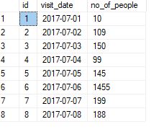
- Desired Output

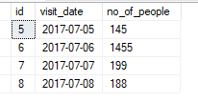
- Apply Filter based upon Problem
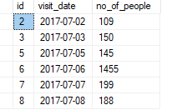
- Give Sequential Number & difference of id & rn

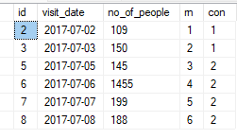
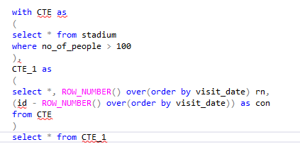

- Result (Output)
